**TOOBUR**

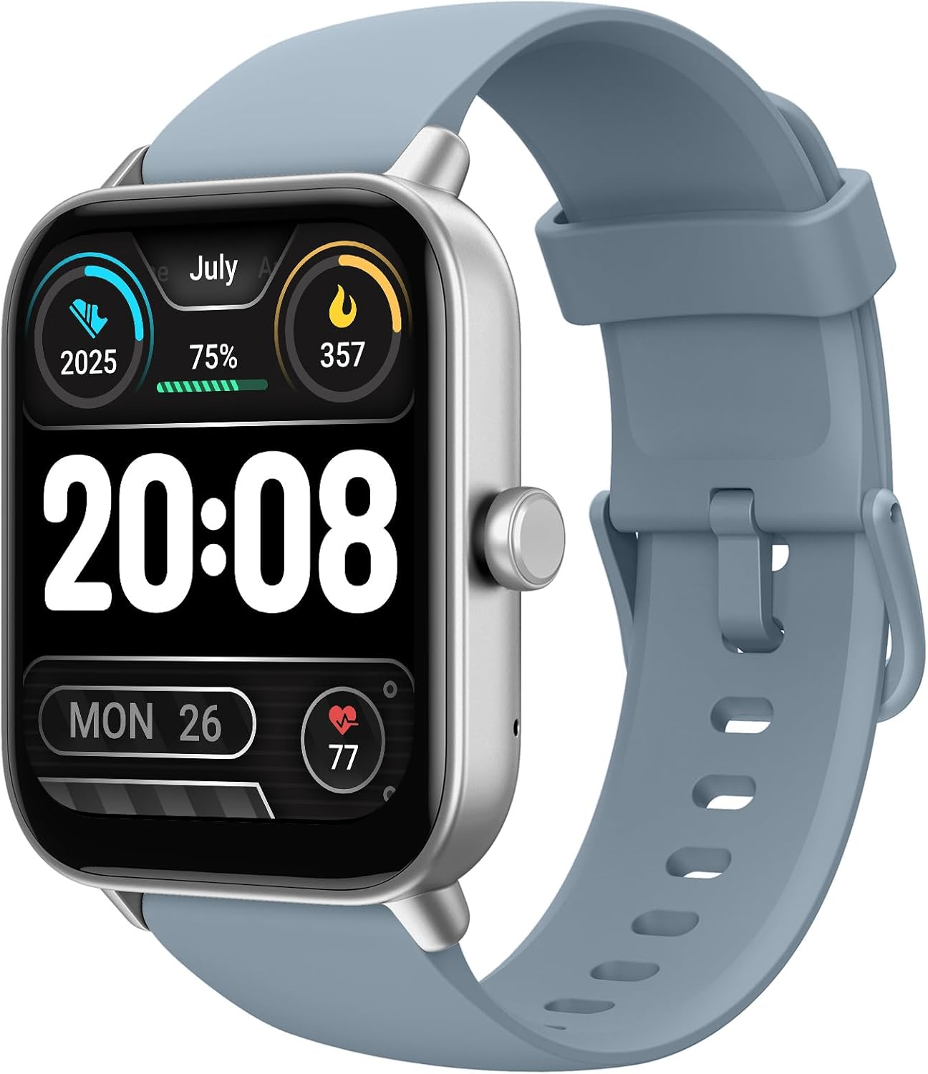

Description: It seems like you're asking for a paragraph about **Taboor watches**. While there isn't widely available information on this specific brand, it’s possible that Taboor is a newer or niche watch brand. Like many emerging watch companies, Taboor may offer a range of timepieces, possibly including options like analog, digital, or smartwatches, designed with a focus on style, affordability, and functionality. Watches from such brands often cater to customers looking for quality without the hefty price tag of more well-known luxury brands. If you have any more details about the brand or the type of watch you're referring to, feel free to share!